Title:
Recorder Teams Manual – V4

Date: | 01 June 2026

Prepared by: | Mark Bignell

Doc Ref: | Recorder Teams Manual

Table of Contents
1 Some History 3
2 Introduction 3
3 Installation 4
3.1 Downloading Recorder 4
4 Recorder Teams Software 4
4.1 Starting 4
4.2 Selecting the data file 6
4.3 Setting up the competition 7
4.4 Creating a Worksheet 10
4.5 Importing and Initial Setup 10
4.6 Editing the Teams 16
4.7 Editing Pilots 17
4.8 Editing Judges 18
5 The competition 19
6 Updating The CIVL Website 22

Some History
I have been running recorder systems since the first World championships in 2000. We started with a caravan and a dB3 database. We would make name tiles and manually keep the scoreboard up to date by moving tiles around.
Now, we got this Texair system with some software, designed to run parachute accuracy competitions. The software was a bit complicated and not really suited to paragliding accuracy.
This software was developed to handle the current competition rules and to give us the opportunity to improve and evolve competition recording as the sport evolves.
We can directly access the Texair equipment which allows us to log pad and anemometer output. If in the future, we change equipment we can adapt as required.
We started with a Python application which allowed us to find out what was really needed. Python is completely open and easily modified. However, deployment and installation is over complicated. Errors are easily introduced.
Now we have re-written the software using c#. This has solved the deployment issues.
Recently, we have added another application called Scoreboard. This handles a series of LED giant screens. There are screens for landing, and current standing displays. This is achieved by setting up a local area network. This is a bit complicated so we are working on a solution that can use an internet link. We also added the capability to use PatPad equipment.
Version 4 now has been updated to handle the rule changes made in 2026. Knockout is still available even though it has been removed from CAT1 competitions. There is now a facility for measuring wind after the pilot has landed.

Introduction
The paragliding accuracy competition recorder application has been created to assist the Recorder in running the administration tasks required during CAT1 and CAT2 competitions.
The system will interface with a Texair or PatPad AMD and anemometer. This is not mandated, and most functions can be used manually.
The Recorder can store information for Country or team; Pilots; Judges and scoring.
The scores for individuals; teams and females are collated and at the end of the competition the report required by the CIVL office can be created in the “correct” format. The templates used to transfer data are continually evolving, this has required some edits to the software over time. Some of the templates can be serviced within excel but the team template will need some manipulation which we will go into later.
The data used by the system is stored in a Microsoft Excel spreadsheet. This has the advantage that all printing is performed within Excel. Minor edits can be performed easily and if more reports are required, they can be created within the sheet.
The recorder PC is connected to Dropbox allowing data to be shared.

However, if the format of certain sheets are changed this will cause the software to fail. All sensitive formatting is covered within this manual.
Do not open the spreadsheet while the application is running. Your edits will not get saved. This is due to the Excel library used in the software.

Installation
The software runs on a PC using Windows 10 or later. It has been run on systems from windows 8 but these older machines have been too slow.
You will need a copy of Microsoft Excel. This is not included with the software.
The system should work with one of the open office systems but to date this has not been tested. Please bear in mind that the data file must be of an Excel format.

Downloading Recorder
The recorder software is free.
You can get a copy by visiting paragliding-accuracy.com. Go to the tools menu item on the footer.
You will receive a file RecorderTeams.zip.
Create a folder to contain all your accuracy data and move the zip file into the folder. Then extract the zip file. You will find a folder called flags. This folder will get you started with flag images. You can put this folder anywhere that is convenient for you.
You will also find a file called publish.html. Use this file to install the .net framework required by this application. Just hit the install button and follow all the instructions.
Finally run setup.exe and the software will install.

Recorder Teams Software

Starting
It is assumed that the person doing the Recorder role will be reasonably computer literate and is able to use Excel and perform fairly simple tasks on a PC. This is quite deliberate as most automatic scoring systems are unduly complicated and inflexible. Competition organisers and chief judges are famous for asking for ad hoc reports with no warning!

When you first run Recorder it will ask if you want to make a new worksheet you may also get a message that no teams are available. Just answer yes and continue. You will be prompted to select a folder, a worksheet name and a competition name. The new worksheet will be created in the folder you selected.
You can also create a new worksheet by selecting Tools from the main menu and then select Make Worksheet.
OK, I knew you had to open it so let’s look at the blank spreadsheet.
There are 14 sheets! Each one stores data in obvious formats. All the sheets that the system uses are coloured orange. There are a few functions and calculations, mostly on the top row. There are column titles on the second row. Data will get entered by the system on subsequent rows.
Let’s explain each sheet:
Teams:
This sheet holds the information for the teams entered in the competition. In CAT1 competitions The team name will be Nation. In CAT2 competitions the team names could be anything, usually the pilots think the team name is funny! The recorder doesn’t care and rarely sees the joke. Each team has a team size, it is important that the team sizes add up to the number of pilots in the competition. If the draw is made by teams the draw numbers are entered into this sheet.
Pilots:
This sheet holds all the information about the pilots. Most of it can be imported from the CIVL website. We will go into that later. The pilot number initially is set but when the first flying order is set the pilot numbers will be changed depending on which draw method is used.
Judges:
This sheet is for your records. CIVL records the judge participation on its website.
Order:
This sheet contains the flying order. After the last standard round and depending when you setup the start of the knockout process this will need to be reset each 2 round cycle.
Scores:
This is a history sheet and each time you enter a flight a record will be made. This sheet is useful when there are complaints as the time allows the wind speed to be checked. It also records re-flights and warnings.
IndividualRaw:
This sheet is required because there are situations where pilots can be removed from the individual knockout but they are still part of a team that qualified.

IndividualStanding:
This is the main record sheet for individuals.
TeamStanding:
This is the main record sheet for teams.
FemaleStanding:
This is the main record sheet for females.
JuniorStanding:
This is the main record sheet for juniors.
MasterStanding:
This is the main record sheet for masters.
RptI:
This is a demonstration report sheet. You can expand row 1 and included titles and import logos. In this sheet you can also change the column titles. This may be required if you want to use a local language. In the past, I have even merged the cells in column S and included logos.
There some handy formula in this sheet for you to copy.
Later, you may want to create report sheets for the other competition categories.
Have a look round but don’t edit anything at this stage. When you are fed up with looking at a blank spreadsheet close it.
Make a shortcut and put it on the desktop. You will find it easier later when you start embellishing the reports.
There is a menu item called paragliding-accuracy website. This link will take you to the tools menu where there are links to the CIVL website for rankings and competitions.

Selecting the data file
You can now double click this shortcut and the system will start. Here is the front screen.
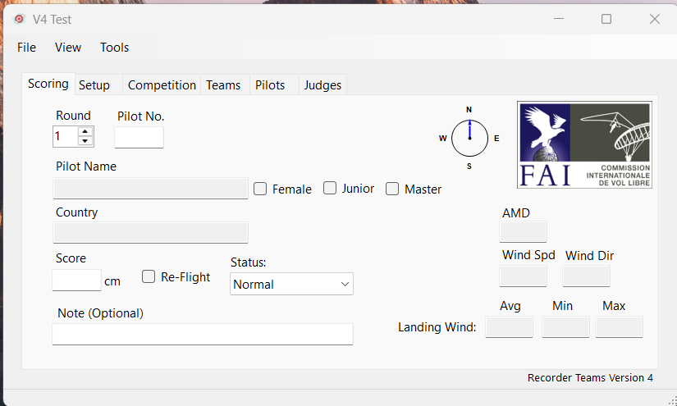
We don’t need this screen yet.
Select Setup.
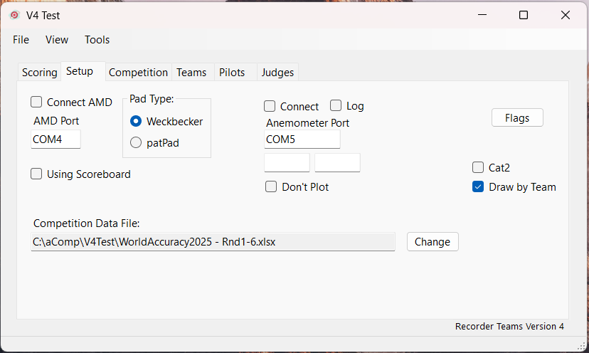

Double click the competition folder box or the change button to point to the file you made earlier. The application will re-start to read the new spreadsheet.
If you are using the scoreboard software you will also need to check Using scoreboard and choose a shared folder location.
For convenience and ease of support use the Dropbox folder to store data. This will be updated if the scoring PC is connected to the internet. This will also enable remote support. There is also a copy of TeamViewer on the PC to enhance remote support.
If you are connecting to the pad you will need to enter the appropriate port and pad type.
There is a button called flags. This will allow you to import the flags for the countries being used in the competition.
Select which type of pad you are using.
Put the anemometer COM port into the Anemometer port box. When you have it connected you can connect, log and plot the data. The compass on the front screen will also be updated.
Select the type of draw you will use. You can draw by team or pilot. If you go into the flying order menu item under tools there are more options for making the flying order.
Check Knockout if you are using the Knockout rules. The current version uses May 2025 rules.
Check if Cat1 or Cat2.

Setting up the competition
Go to the Competition tab.
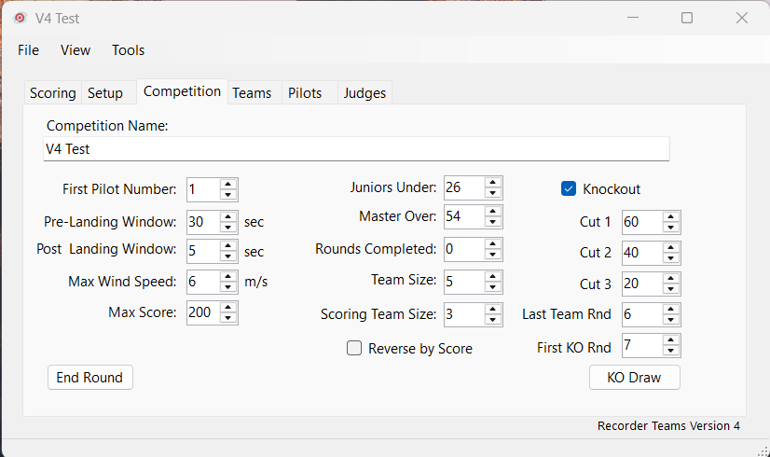
Use the items on this panel to set up the competition.
- Competition Name
This is the Name of the Competition
- Team Size
This can be any number from 3 to 7
- Maximum Score
The maximum score used when a pilot misses the target.
- Scoring Team Size
The number of pilots whose score will be counted towards the team score. The system will use the best scores according to the Scoring team size.
- Maximum Wind Speed
The maximum wind speed after which a relaunch will be offered.
- Wind History
When the wind speed indicator is connected the system will keep a record of the wind speed in the set period. The maximum value is recorded when the pilots score is entered. This field is redundant as the log check box on the previous screen will record all data.
- First Pilot Number
The first pilot number used when the flying order is produced.
- Junior Under:
Age that a pilot qualifies as junior. You must do this before and data is imported.
- Master Over:
Age that a pilot qualifies as master. You must do this before and data is imported
- Rounds completed
The number of rounds completed in the competition so far.
If you are using knockout rules check the knockout box and update the appropriate settings shown below.
- Last team round
This is the last round for which the team score will be calculated before a cut takes place. If there is no cut put 13 and no cut will occur.
- First KO Rnd.
This is the first round where the cut starts
- First Cut
Number of pilots to survive the first cut.
- Second Cut
Number of pilots to survive the second cut.
- Third Cut
Number of pilots to survive the third cut.
The KO draw button will execute a draw according to the settings above.

If you have incomplete teams use the end round button to update the team scores at the end of each round.

Creating a Worksheet
You already did this but we need to explain separately too. Before we can do anything we need to create a data file to contain all the competition results.
Got to the main menu and find Tools->Make Worksheet and click it.
You will be asked for a location, file name and the competition name. The new file will be created and Recorder Teams will restart. If you want to inspect it close Recorder Teams and look around. Don’t change anything at this stage as you don’t know what is important. There are structures in the sheets that if changed will mean that Recorder Teams will fail.

Importing and Initial Setup
To make things easy you can ask the competition organiser to download, in Excel format, the competition participants list from the CIVL website.
Now you can go to the tools menu in the Recorder app and import the participants. So use ToolsImportParticipants. You will get a warning and then will be prompted for the participants file name. Select the participant file and click Open and the app will import all the Countries, pilots and set the rankings.
If you are an experienced recorder you will know that the pilots are rubbish at putting accurate data into a form so, we will now close the app and open the competition Excel file and check the data. We don’t need to check everything. We check the things we need to run the competition scoring.
Go to the Excel Data menu and highlight all the titles in row 2, if you haven’t added any columns to the end it should be A to U. Now click the filter icon under sort and filter. Now you can use the drop down buttons at the top of the columns to sort the list by country. This will make it much easier to edit the file.
First check the first and last names. I like then to have a capital letter at the start. The pilots will see the scoreboard name on all the reports so make sure they are correct.
Check the Nation column. This will be used to select the country flag image.
The team position will be important for the flying order. Adjust the team positions to match the data supplied by the team leaders. You can do this using the app but it is much faster just editing the Excel file.
Count the number of individuals that are in the competition. You will need to setup individual teams to handle them during the competition. If you are using draw by pilot I just create a team called “Individual 1” and put them all in this team. Team name starting Indiv will be ignored for the team competition.
Now go to the Teams worksheet. All the teams that registered will have been imported. Enter the team size for each country in the allocated team size column.
You should end up with something like this:
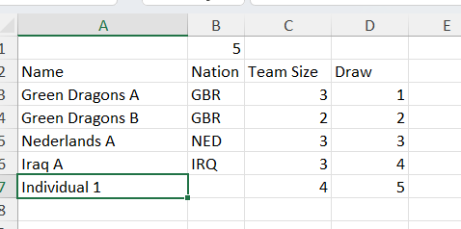
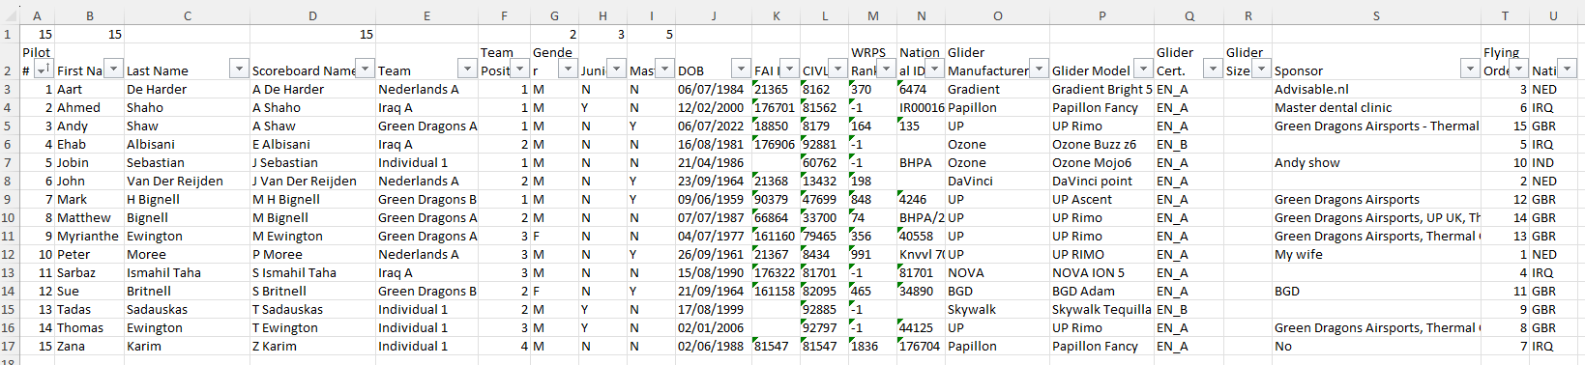
If the draw has been made put the draw number into the Flying order column. That will be column T in Pilots if you are drawing by pilot or column D in Teams if you are drawing by Nation/Team.
Now go back to the Pilots worksheet and assign all individual pilots to a team and a team position. This can be random or you can get the pilots to draw lots. Don’t change the pilots Nation.
Note: Make sure that the team names are exactly the same in the pilot sheet and team sheet or Recorder teams will be unable to update teams correctly.
Save the spreadsheet and close the file.
Restart the app.
You should now have a list of the countries.
You should also have a list of all pilots.
You may also notice that some or all of the flags are missing. We can fix that.
Go to the setup tab and click the flags button. You will get a window with all the imported flags.
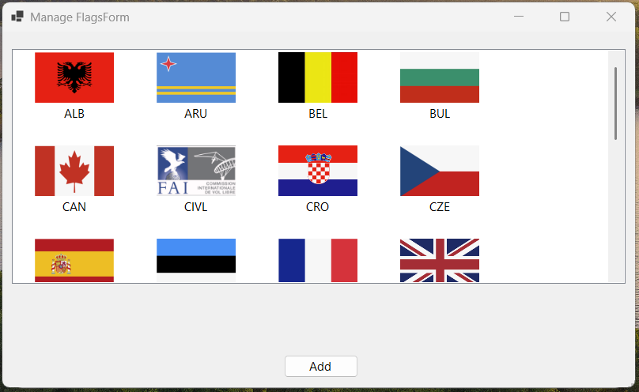
The easiest way to get accurate images of the flags is to search for the flags on the internet and use the snip app to copy the image then save it to a folder. The size isn’t important but make them big enough to get all the detail. The app will rescale them to suit. You have a reasonably good start in the flags folder supplied with Recorder-Teams. There is a zip file on paragliding-accuracy.com which you can download.
Use the Add button to import the file into the Recorder Teams. Use the Country short name as the file name when prompted. Close the manage flags form by clicking the X icon. The flags will appear when you restart Recorder Teams.
Go to the Tools menu and click Flying Order. You will be presented with a warning click yes and the flying order will be created. This function will also setup the Individual, Team, Female, Junior and Master worksheets.
You can check the sheets by viewing the standing sheets. From the View menu select Individual Standing and a new window will appear showing all pilots. You can do the same with menu items. Alternatively you can close the app and open the spreadsheet directly.
Until the start of flying you can run the Flying order function as often as you wish.
You may want to go into the spreadsheet and format the flying order. The top row has been left blank so that you can add a header. You can change the row height and merge columns to add titles and pictures. You can even add borders. Here is one I did:
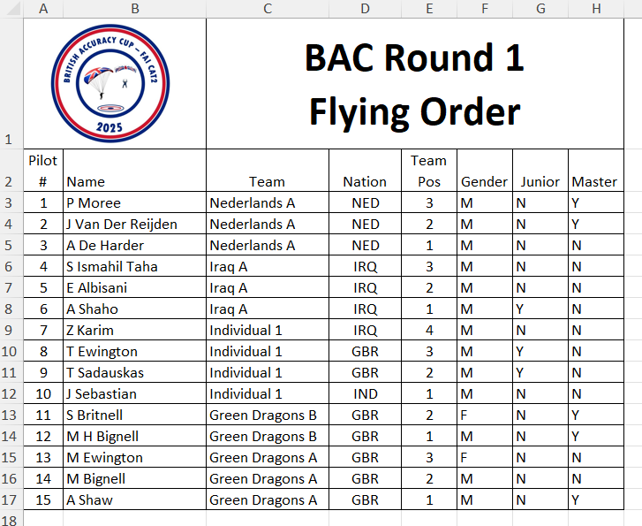
This can then be printed for the Launch Marshall and the judges. Of course they will always ask for something different so you can create a bespoke sheet for them. I created a sheet called RptLM:
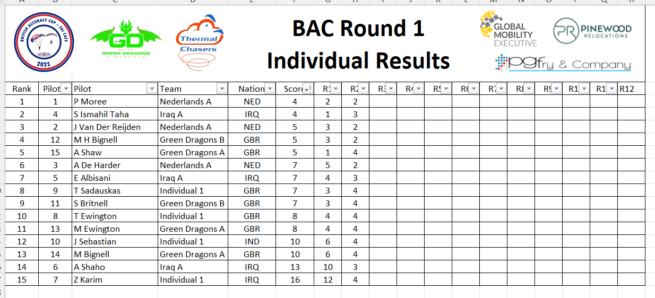
Put =IF(LEN(IndividualStanding!B3)>0,IndividualStanding!B3,"") into cell B3 and press enter. Then copy across to cell D3 using the dot handle situated in the lower right of the cell. Use the same format F3 but use I3 in the formula then copy that to all the other cells in row 3. Then highlight all the row and copy them down to the end of the pilot list.
You can make as many sheets as you want using the same method. I created one for collecting signatures (now redundant). However, this format can also be used to make a written record of each round. Just add a box at the end for the Chief Judge to sign once checked.
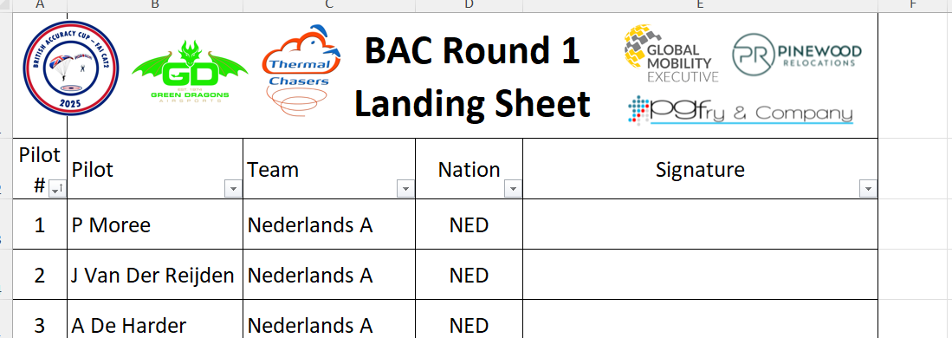
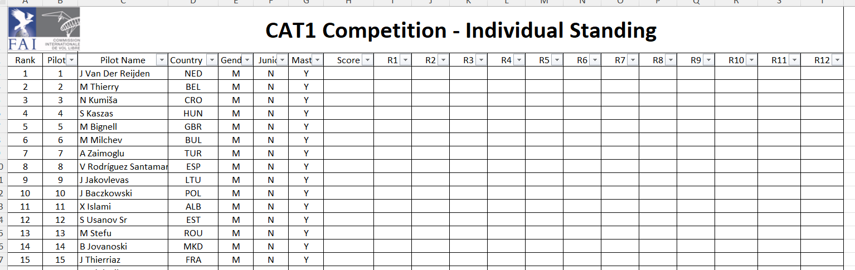
Note that I have set the filter from column B to T. Now when I want a report I can sort the score from smallest to largest and keep the rank.
You can do the same for Team, Female, Junior and Master by creating sheets and copying data from the appropriate worksheet.
The software includes a facility to display the details of the last pilot to land on a separate monitor where the spectators can see it.
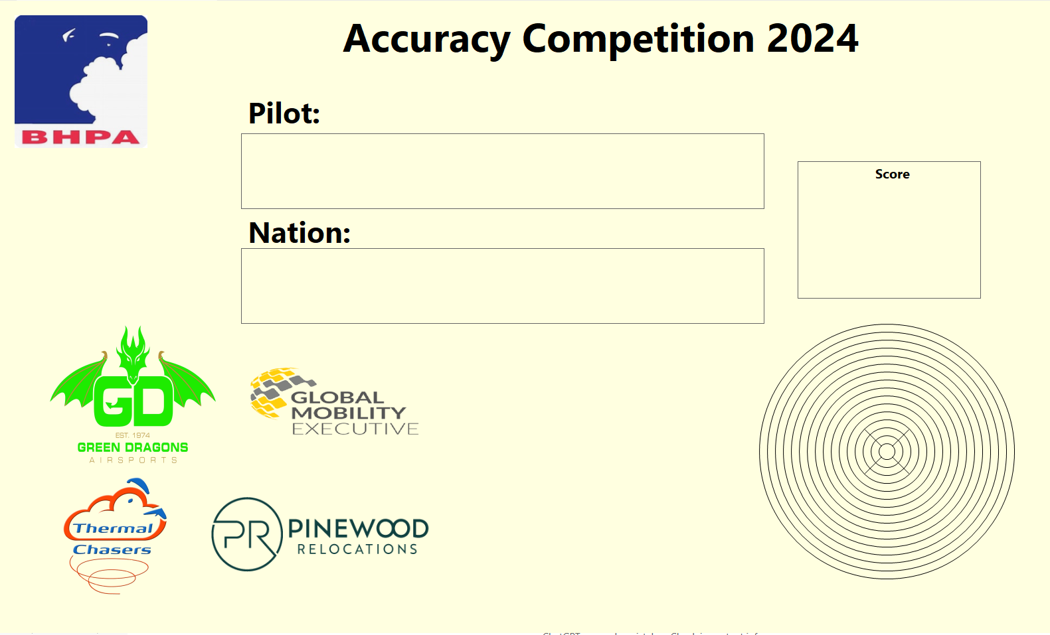
At this stage you may want to setup the Landing Screen.
The competition title is taken from the competition name you entered earlier.
When the recorder enters the data from the last pilot who landed. The name, nation, nation flag, score and pad location, if you are using a PatPad, will appear.
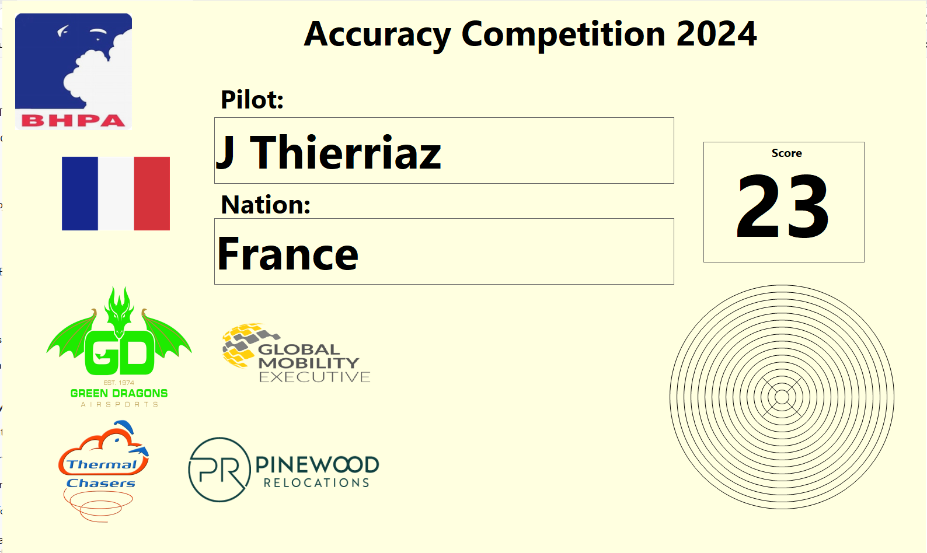
You can manage the logos using the manage logo item which can be found under the View->Landing Display->Manage Logos
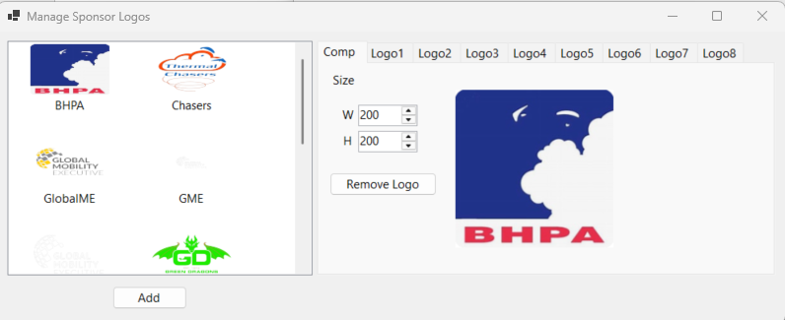
You may not have any logos. Use the Add button to load your logos, png format, into the app.
You can select the appropriate tab and double-click a logo in the righthand box and it will appear in the left. You can use the W and H field to alter the height and width of the logo.
Use the remove button to clear the logo.
When you are done close the manage logo screen.
Display the landing screen using View->Landing Display->View.
The logos may be the wrong size or in the wrong place.
Hover the mouse pointer over a logo and move by pressing and holding the left button, move to the new place and release the mouse button.
Change the size by hovering the mouse pointer over a logo, press and hold the Ctrl key. Four handles will appear. You can then use the handles to resize the logo. When you are done release the keys and the handles will disappear.
You may find that an unused logo is obscuring one of your logos. Just use the move facility to put it in a position that doesn’t ruin the look of the display.
You can also manage the colours used on the landing display. Use View->Landing Display->Setup.
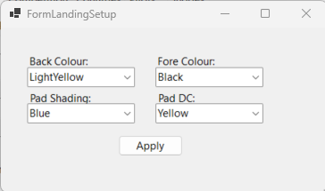

Set the colours as you wish by using the dropdown boxes then press apply.

You are all setup.

Editing the Teams
Select the Teams tab.
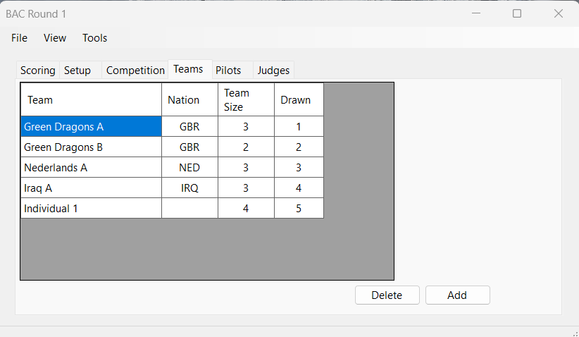
The teams in a CAT2 competition are up to the clubs/pilots. They can, however, be teams of 3 to 7 pilots depending on how you setup the competition.
Use the Add button to enter the teams.
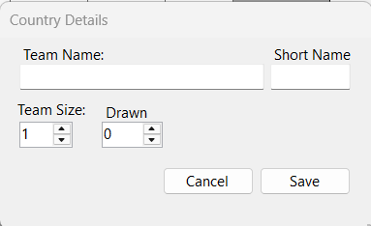

Enter the team’s name and a short code into the initials. Select the team size and draw number if it’s going to be used.
When completed press Save and the data will be entered into the country sheet. Press cancel and no data will be entered.
The data in the table may be edited by double clicking the row.

Editing Pilots
Go to the Pilot Tab.
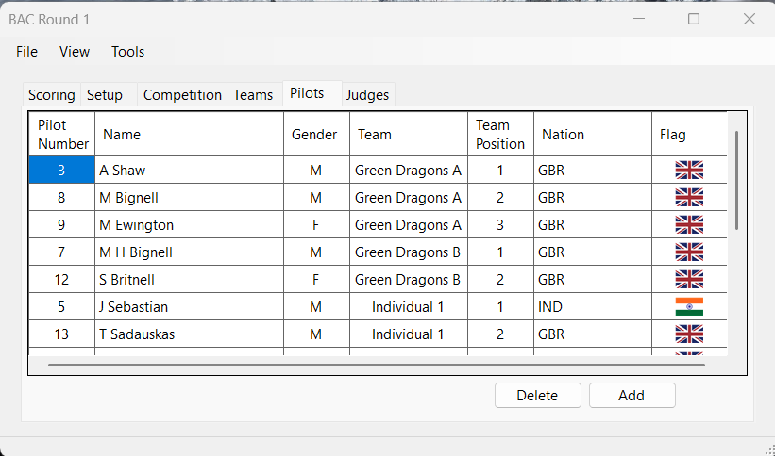
To enter Pilot data, press the Add Key.
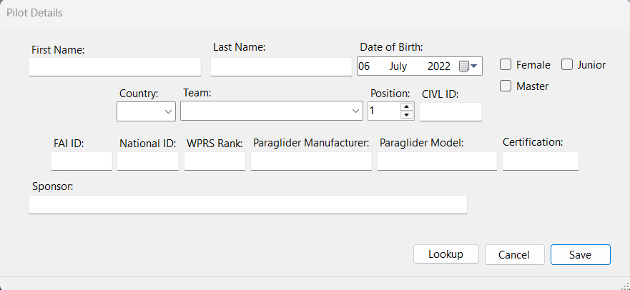
There is a lot of data in this Tab not all of it is required for CAT2. Most of the data is self-explanatory.
The Country tab will be filled with the short name used for each Team.
Check the female check box for females.
Team position is import when setting the flying order by team.
It is important to check FAI sporting license and record the CIVL ID if the CIVL report is to be sent to gain WRPS points. Hopefully, they will be in the participant list you downloaded.
Master and junior will be selected when you enter date of birth according the ages you setup.
Use Save to enter the data into the pilot sheet or cancel to exit the window with no save.
The data in the table may be edited by double clicking the row.
Again, I would normally enter the pilot data directly into the spreadsheet. This way I can check the CIVL identity using the FAI website.

Editing Judges
Before you try and setup judges you need to check the list of judge roles in the spreadsheet Judges column J. the application will fill the role list with these roles. You can add as many as you want. Here is what I put in:
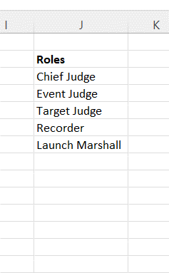
Remember you have to stop the application! Save the sheet and re-start.
Go to the Judges tab.
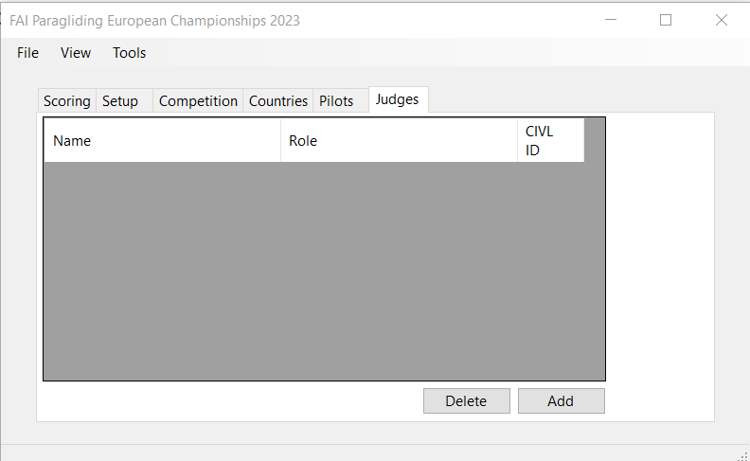
If any data is to be sent to CIVL in order to register WRPS points the judges must be listed.
Use the Add button to add judges.
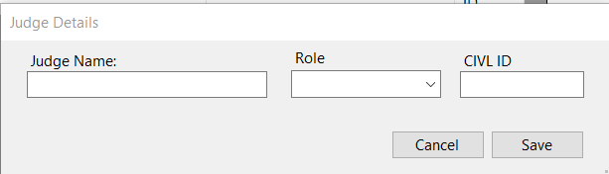
Enter the judge’s name, their role and CIVL ID. Use 999999 if the judge has no CIVL ID. The CIVL office cannot enter judges so these judges must log onto the FAI website and register themselves.
Use the Save button to enter the data or cancel to exit without saving.

The competition
The target area will be setup by the Chief Judge. If the AMD system is being used, then the USB can be connected to the PC.
Use the device manager to check which COM port is being used. Open Ports (COM & LPT) to see COM ports in use. Below you can see Arduino. I am using an AMD simulator based on an Arduino. If you are unsure which port to use, disconnect the AMD USB and one of the ports will disappear. Reconnect and use the port Identified in the list.
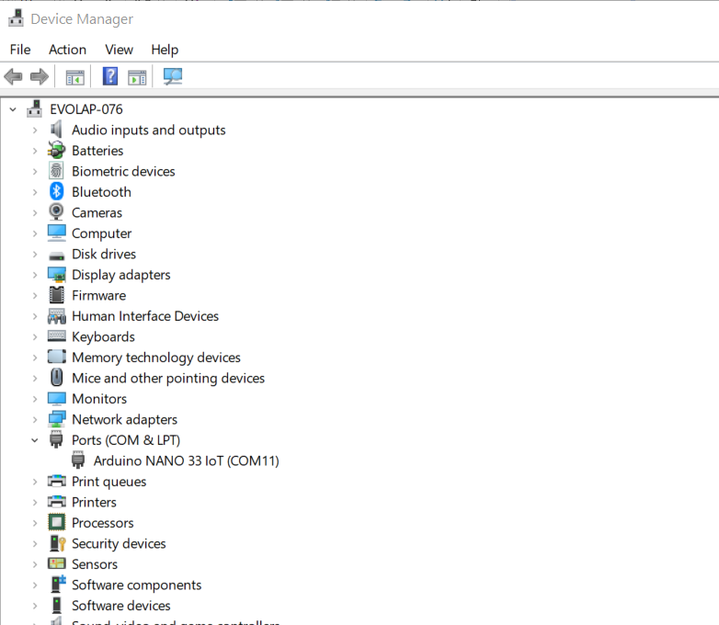
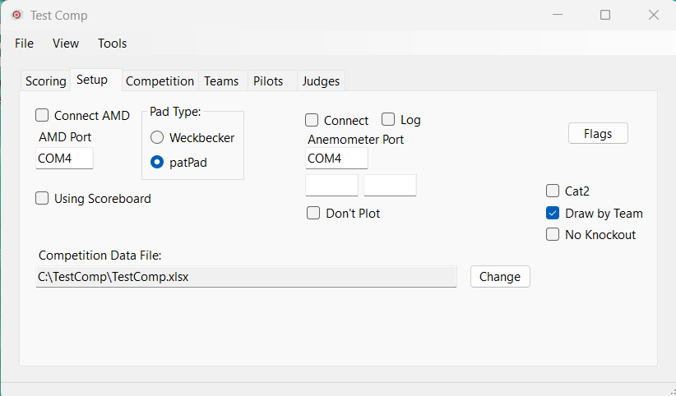
Go to setup and enter the AMD COM port and the pad type.
Set the Anemometer port if you have one connected.

When the AMD is powered up and running, check the ‘Connect AMD’ box and the system will connect.
When you connect the Anemometer values should start appearing in the 2 boxes below the port. The compass and wind speed should also start appearing on the Scoring panel.
When you check the Anemometer log option a file will be created in your competition folder. There will be one for each day of the competition. One record is recorded each second with a date and time. You can also check the plot option and you will get a plot of the last 30 minutes wind speed.
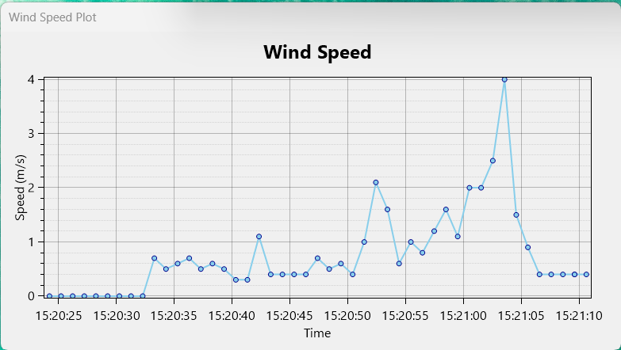
You can use the mouse wheel to zoom in or press the right mouse button and pan the image, change the axis ranges in the same way. You will see a red dotted line at the max wind speed.

Go to the Scoring tab.
Now you should see the wind direction and wind speed go live and when the pad is struck the score will appear in the Pad and score boxes.
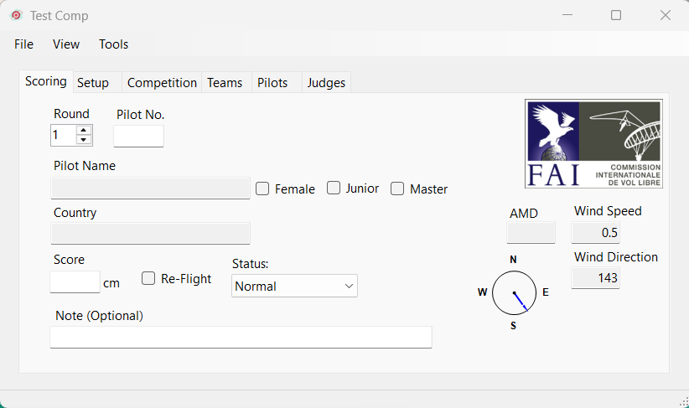

You may find it useful to view the individual standings onto the second monitor. Use the View menu item and check the view you need. This is the best way to keep track of what has gone into the competition so far.
Now we just need some pilots to begin the competition.

Check the round box is set to the correct value.
If, during the competition things get complicated and pilots fly out of order you can change the round number as required. If you do make a mistake the application will not let you put data into a cell which is already occupied.
Now, when a pilot scores and the judges have called the score put the pilot number in the ‘Pilot No’ box and press enter. Everything else will get filled in by the application and the cursor will go to the ‘Score’ box.
Enter the score declared by the judges, press enter, and the spreadsheet will be updated. Enter the score in centimetres. E.g., 1.5m would be 150.
If the judges call a re-launch, then check the re-launch box and the score will be recorded but not included in the scoring. Use the drop-down box to mark records with special circumstances such as did not fly, or warning given.
All scores are entered into the scores sheet together with the date and time that the flight was entered. When you are connected to the AMD the maximum wind speed in the wind history period set in the competition setup. All wind data is also saved in the wind history data file.
When a round is complete, we can use the end round button. This will modify the team scores where a team is short of scoring members by adding a maximum score for each missing member. If you are not using a knockout do this on every round. If you are using a knockout the only use the end round up to the point where the knockout starts. After that the knockout software takes care of the missing members if they exist.
When there is a knockout before you start the first knockout round you will need a new flying order. Set the round number on the scoring panel to the first knockout round. Then use the apply KO button. This will create the new flying order with the leading pilot last. All pilots that did not survive the cut will be marked DNQ. There may be pilots that did not make the individual cut, but they get in the flying order if they are in a top 6 team, top 6 female or junior. Their scores will not be entered in the individual sheet but they will go in female and junior sheets and be used to calculate top 6 teams.
The knockout assumes 2 rounds at each knockout stage and you will need to create a new flying order for each new cut. We will probably increase the flexibility in the future if the rules change but for now this is complicated enough.
At the end of each knockout phase, go into the spreadsheet insert a blank line above the last qualified pilot. Then sort the qualified pilots by score (smallest to largest). Then remove the blank line. This will make any printouts much clearer.

Updating The CIVL Website
At the end of each round, and the competition, you may want to upload the latest scores to the CIVL website. Use Tools->Make CIVL Report->[one of the overall reports]. This will create a file in the competition folder compatible with the CIVL import requirements.

