Windy MetOne Application

User Manual
FAI CIVL

1. Introduction
The Windy MetOne Application provides real‑time monitoring, logging, and graphical display of wind speed and direction data from MetOne anemometers. It is designed for FAI CIVL operations requiring accurate on‑site wind tracking, such as air sports competitions and meteorological monitoring.

2. System Requirements
• Windows 10 or Windows 11 (64‑bit)
• .NET Framework 4.8 or later
• One free USB port
• FTDI USB‑to‑Serial drivers installed

3. Installation
1. Download and unzip the Windy MetOne Application package from:
https://paragliding-accuracy.com/index.php/tools/
2. Run WindyMetOne.exe.
3. If prompted, install the FTDI drivers from https://ftdichip.com/drivers/ (choose Windows x64 setup executable).
4. Plug in the MetOne anemometer using the FTDI USB cable.
5. Windows should detect the device automatically.

4. Connecting the MetOne Anemometer
1. Launch the application.
2. Ensure the anemometer is connected via the FTDI USB cable.
3. Click the **Connect** checkbox.
– The application automatically locates and connects to the correct FTDI device.
– The title bar shows the selected data folder.
4. Once connected, the live wind speed appears on‑screen and is logged automatically.

5. Live Operation
• Wind speed is displayed numerically and graphically in real‑time.
• The graph scrolls smoothly, showing the latest hour of data.
• The Y‑axis automatically scales from 0 to (max speed + 1 m/s).
• A red dashed line marks the maximum wind threshold.
• Data is logged once per second into the current day’s file.
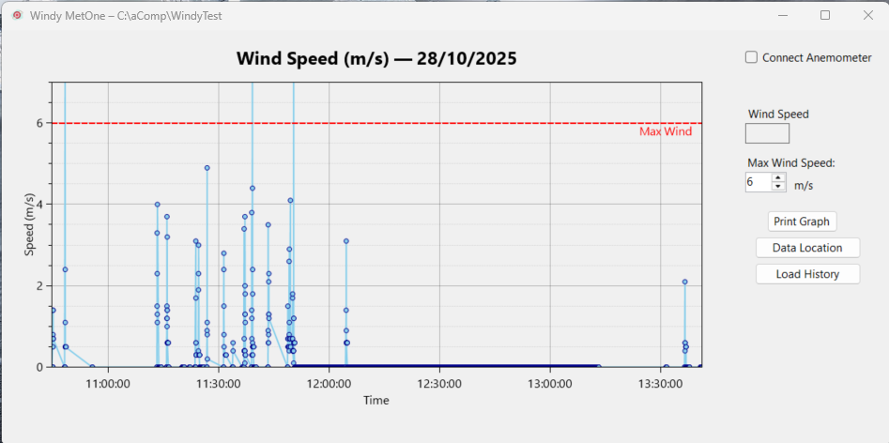

6. Logging and Data Files
The system logs all readings automatically while connected.
• Logs are stored in the selected **Data** folder.
• Each day creates its own file named `Wind_YYYYMMDD.csv`.
• Example: `Wind_20251027.csv`.
• Format: `Date, Time, Wind, WindDirection, OverLimit`.
7. Viewing Historical Data
To review previous days:
1. Ensure the system is **disconnected**.
2. Click **Load History**.
3. Select a CSV file from the Data folder.
4. The graph updates to show all readings from that day.
5. When you reconnect, the graph automatically switches back to today’s data.
8. Printing Graphs
Use **Print Graph** to produce a scaled landscape printout of the current graph.
A print‑preview window appears before printing.
The print includes the plot title with today’s date and the current time.
[Insert Screenshot – Print Preview]

9. Changing the Data Folder
To change where log files are stored:
1. Click **Change Data Location**.
2. Select or create a folder.
3. The new folder path appears in the title bar.
The setting is remembered for future sessions.

10. Troubleshooting
• **No connection:** Ensure the FTDI driver is installed and the USB cable is firmly connected.
• **Port not found:** Unplug and reconnect the USB cable, then click Connect again.
• **No wind data:** Check that the anemometer is powered and spinning.
• **Log files not appearing:** Confirm that the Data folder is valid and writable.

11. Safety and Notes
• Always disconnect the device before unplugging the USB cable.
• Avoid exposure of the USB adapter to rain or moisture.
• The application writes one line per second; long‑term logging may produce large files.
• Use Print Graph or export images regularly to document conditions.
© 2025 FAI CIVL — Windy MetOne Application User Manual

